  MS Power platform challenge | Abstract  Build a complete application in 6 weeks to become proficient using Power Platform Tools.  Created by  Rafael.Tokashiki.jp@us.af.mil

Operation Fit-to-Fight
911th Wing — Iwo Jima Air Base, Japan
Course Type: Project-Based Capstone Challenge (SharePoint Lists, Canvas App, Power Automate, and Power BI)
Target Audience: Intermediate level Developers / self-motivated learners
Document Version: 1.6

Executive Summary
Section | Details
Mission Objective | Modernize the physical fitness assessment scheduling, execution, and reporting workflow at Iwo Jima Air Base.
Current State | Laminated clipboards, manual stopwatches, paper rosters, and a single-user Excel spreadsheet prone to corruption.
Target State | A secure, relational SharePoint-backed system featuring a responsive desktop app for track evaluators and squadron management, automated scoring flows, and a leadership readiness dashboard.  Developers are free to design and implement the application as long as it covers the basic requirements and the design decisions are explained during the live demo.
Core Architecture | SharePoint Online (4 lists), Power Apps (1 Canvas App), Power Automate (Standard Flows), Power BI.
Prerequisites | Basic knowledge of SharePoint Lists  Basic knowledge of Power Apps, Canvas Apps  Basic knowledge of Power Automate flows (triggers/actions)  Basic knowledge of Power BI  Strong research and coding ability including the use of vibe coding with genai.mil
Goal | The goal is to build a working solution, explore different techniques, and explain tradeoffs during the demo. The challenge is intentionally open-ended. There is no single correct implementation path. Different developers may choose different data modeling, formulas, UI, and automation approaches. For example, calculations could be done in the canvas app or in a flow.
Notice: | This is a hands-on engineering challenge, NOT a step-by-step tutorial. It mirrors real-world operational environments where requirements are defined but the execution path is open. You are expected to conduct independent research, troubleshoot formulas, and leverage your technical ingenuity to build this system.  *Sample data columns and values could be different from table specifications as data is captured by different teams in real projects.

Section 1: The Tactical Scenario
Iwo Jima Air Base in Japan, operates 24/7 in demanding tropical conditions. Every Airman stationed here must maintain peak physical readiness. However, managing physical fitness assessments (PFAs) for over 9,000 active-duty personnel is an administrative bottleneck.
Currently, the Fitness Assessment Cell (FAC) operates on paper rosters and clipboards. When Iwo Jima's summer humidity spikes, the Wet Bulb Globe Temperature (WBGT) index hit "Black Flag" conditions. This forces the FAC to instantly pivot outdoor 1.5-mile runs to indoor alternative locations or shift Airmen to the 20-Meter Shuttle Run (HAMR). On the track, evaluators scribble raw counts on paper. In the chaos of shifting environments, papers get wet, handwriting becomes unreadable, and manual data-entry errors lead to incorrect scoring and administrative backlogs.

Section 2: Target User Personas
You must design your application to address the specific needs of these three core base personas:
Persona Role | Name & Title | Core Duties | App Requirements
Test Candidate | A1C Peter Parker | Needs to register for a PFA session slot and record basic biometrics. | Friendly interface, automated email confirmation, and access to scoring table.
FAC PT Coordinator | TSgt James Rhodes | Coordinate PT session schedules and locations  Coordinate Airmen enrollment | Friendly interface, minimize data entry repetition, display BMI in airmen profile.  Deleting a session slot would cascade delete all registrations for the session.  *Better if it also sends email to all registered personnel
FAC PT Evaluator | TSgt James Rhodes | Conducts the physical test on-site, logs raw heights/weights, and inputs raw reps and times. | Friendly interface, conditional fields for different test options, instant score feedback, and automated email with scores.
Wing Commander | Gen Carol Danvers | Monitors base-wide physical readiness. | Dashboard, statistical views for pass/fail metrics, squadron completions, and other metrics important for the wing

To simplify the user experience and reduce the complexity of the initial build, When the app is first opened, it should display a main menu prompting the user to select the function they are there to perform:
- Registration: Navigates to the screens designed for Test Candidates (booking slots, viewing upcoming tests).
- Evaluation: Navigates to the FAC Evaluator screens (inputting scores, managing rosters).
- Statistics: Navigates to the dashboard view for Commanders.

Section 3: Relational SharePoint List (Database) Schema
You will build 4 SharePoint Lists. 3 of them will be in a data relationship
Column names and data types are suggestions. Review possible data values as this guide has been written as real scenarios where multiple people worked on the requirements. Feel free to generate mock data or use the sample provided (real scenario data is not clean) make sure that the IDs in Slots and Airmen match the ones in registration.
Table 1: PT Assessment_Slots
Column Display Name | Internal Name (No Spaces) | Data Type | Permitted Values / Notes
Title | Title | Single Line of Text | i.e., "Month Week Number"  August Week 1  August Week 1-2
Date | Date | Date and Time | Date
Location | Location | Choice | "Base Track", "Base Gym” “HS Track” “HS Gym”, "Park"
Environment | Environment | Choice | "Indoor", "Outdoor"
Capacity | Capacity | Number | Maximum available slots (i.e., 20)
Status | Status | Choice | "Open", "Full", "Completed", "Cancelled"

Table 2: PT Roster
Column Display Name | Internal Name (No Spaces) | Data Type | Permitted Values / Notes
Title | Title | Single Line of Text | Airman's Full Name (i.e., "Jane Doe")
Rank | Rank | Choice | "Amn", "A1C", "SrA", "SSgt", "TSgt", "MSgt", "Capt", "Maj",”Lt”
Squadron | Squadron | Choice | "911th CS", "911th CES", "911th LRS", "911th FSS"
Email | Email | Single Line of Text | i.e., jane.doe@nomail.com  *use a few real email addresses when testing the automation
Gender | Gender | Choice | "Male", "Female"
AgeGroup | AgeGroup | Choice | "Under 25", "25-29", "30-34", "35-39", … , ”50-54”, “Over 59”
Height | Height | Number | Integer inches (i.e., 68 for 5'8")
Weight | Weight | Number | Weight in pounds (i.e., 175)

Table 3: PT_Registrations
Column Display Name | Internal Name (No Spaces) | Data Type | Permitted Values / Notes
Title | Title | Single Line of Text | Unique code (i.e., "REG-2026-5001")
SlotID_FK | SlotID_FK | Number or lookup | link to PT_Assessment_Slots
AirmanID_FK | AirmanID_FK | Number or lookup | link to Airmen_Roster
*Note: You may use either proper Lookup columns or Number columns storing the ID. Both approaches have trade-offs. Research delegation and performance implications.
Status | Status | Choice | "Scheduled", "Incomplete", "Completed", "No Show"
Cardio | Cardio | Choice | "1.5_Mile_Run", "20_Meter_HAMR"
CardioMinutes | CardioMinutes | Number | Minutes for 1.5-mile run
CardioSeconds | CardioSeconds | Number | Seconds for 1.5-mile run
CardioHAMRLaps | CardioHAMRLaps | Number | Completed shuttle laps
UpperBody | UpperBody | Choice | "ST_Pushups", "HR_Pushups"
UpperBodyCount | UpperBodyCount | Number | Completed repetitions
Core | Core | Choice | "Situps", "Crunches", "Planks"
CoreCountTime | CoreCountTime | Number | Rep count, or total seconds held (i.e., 180 for Plank)
CardioPoints | CardioPoints | Number | Use the score matrix to find the score for Cardio
UpperBodyPoints | UpperBodyPoints | Number | Use the score matrix to find the score for Upper Body
CorePoints | CorePoints | Number | Use the score matrix to find the score for Core
TotalScore | TotalScore | Number | Sum up score. Max 100
Result | Result | Choice | "Excellent 90+", "Satisfactory 75-89", "Unsatisfactory 75-"

Table 4: PT_Scoring_Matrix
This reference table houses the official grading scales. Query this list to dynamically look up and award points based on the candidate's age, gender, and raw performance metrics.
Column Name | Internal Name | Data Type | Permitted Values / Notes
Matrix ID | ID | Counter | System Generated. Primary Key.
Title | Title | Single line of text | Descriptive identifier for the rule (i.e., "Male_Under_25_Pushups", "Female_30-39_20_Meter_HAMR").
Gender | Gender | Choice | Male, Female
AgeGroup | AgeGroup | Choice | "Under 25", "25-29", "30-34", "35-39", … , ”50-54”, “Over 59”
Component | Component | Choice | Pushups, Situps, Run
MinScore | MinScore | Number | Integer. The minimum performance threshold for this point bracket (i.e., 33 pushups, or 0 seconds for a run).
MaxScore | MaxScore | Number | Integer. The maximum performance threshold for this point bracket (i.e., 66 pushups, or 622 seconds for a run).
Points | Points | Number | Decimal. The points assigned for landing within this raw score range (i.e., 15.1, 20.25, 60).

Section 4: Course Deliverables & Milestones
You must complete and demo (live presentation) the following milestones to successfully finish the project:
Course Milestones & Deliverables Checklist
Phase | Milestone Title | Student Deliverables
01 | Relational Data Architecture & Orphan Cleanup Flow | 1. Design a relational data model with SharePoint Lists. Build four lists: PT_Scoring_Matrix, PT_Assessment_Slots, Airmen_Roster, and PT_Registrations.  2. Validate and import source data  3. Notify registered airmen that the session slot they signed up for was rescheduled.
02 | Operator Interface | 1. Responsive Desktop App: Build a landscape-oriented canvas app screen.  2. Conditional Screen: Implement dynamic input fields that show/hide based on the candidate's selected cardio component (1.5-Mile Run inputs vs. 20 Meter HAMR Laps) and core component (Situp counts vs. Plank timer).  3. Biometrics Calculation: Display airman’s BMI based on his height and weight inputs.  4. Automatic email to registered airmen  5. Use scoring matrix to calculate results
03 | Command Desktop Portal | 1. Roster Scheduling Hub: Design a split-screen dashboard to filter testing sessions and manage candidate lists.  2. Roster evaluations for any given session slot. Show all airmen registered for the session slot and allow input their results.
04 | Operational Automation & Alerts | 1. Confirmation Flow: Create a flow that emails airmen a confirmation listing the test date, and location.  2. Grading & Alert Flow: Build a flow triggered by a "Completed" test to automatically send an email to the candidate with the score.  3. Delete registrations when a session slot is deleted. Better if it also sends notification emails to all registered airmen.
05 | Mission Readiness Analytics | 1. Power BI Desktop shows data relationships  2. DAX Measures Suite: Code three DAX calculations: Average PFA Score, Unit Pass Rate %, and failure driver(exercise) rate %.  3. Single page high impact dashboard with visuals for:  Wing readiness  Total personnel, total registrations, total assessments completed, total assessments completed successfully, average total score.  Fitness failure drivers show a chart with the avg scores for each individual component (exercise). This should show which component is dragging down the wings’ overall scores.  Other visuals may include information broken down by squadron, ranks, gender, and or PT exercise.
06 | Performance | - No app crashes  - Easy to use interface
07 | Security | - Explain how you plan to secure the app to avoid Airmen being able to modify their results, view other airmen’s results, or view the commander’s dashboard.
08 | Improvements | - How would you enforce capacity in assessment slot?  - How would you deal with schedule changes?  - What would you change to make it better?  - What would you add to make it better?
09 | Lessons learned | - What was the most difficult thing you learned?  - What would you make differently next time?

Suggested Screen Design
- Canvas App home screen
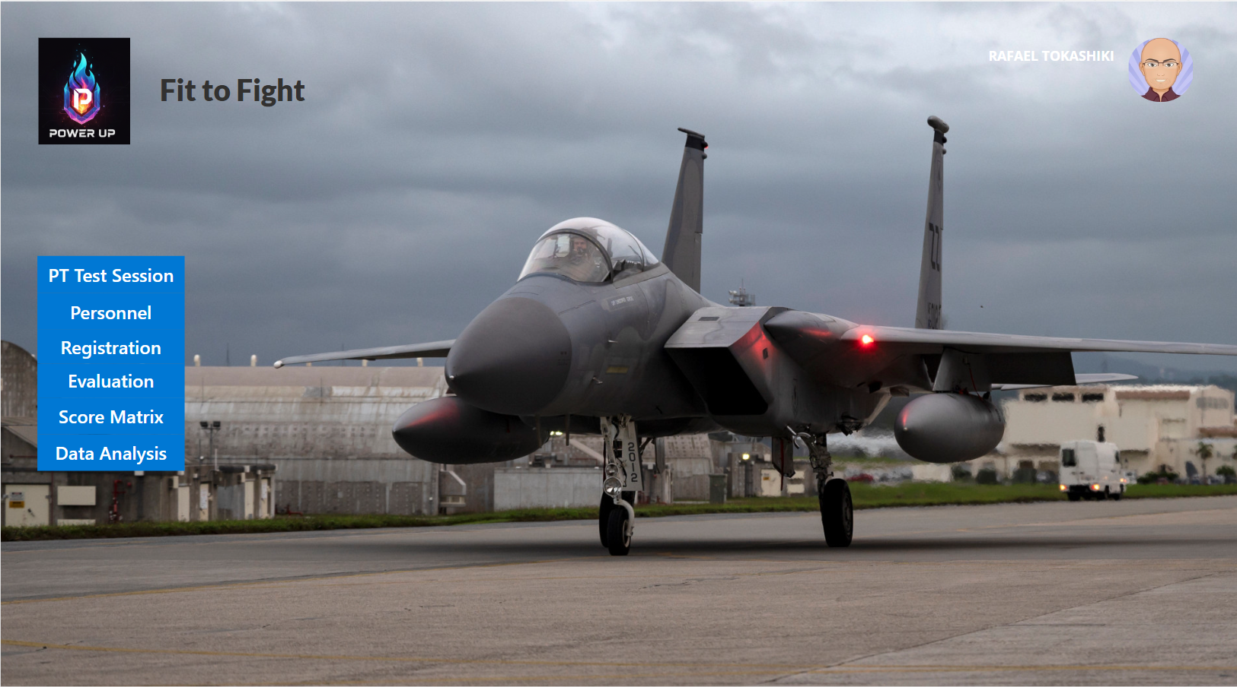

- Data Screens
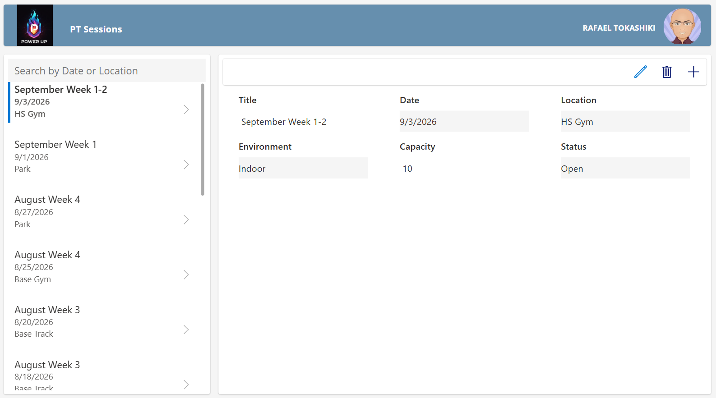
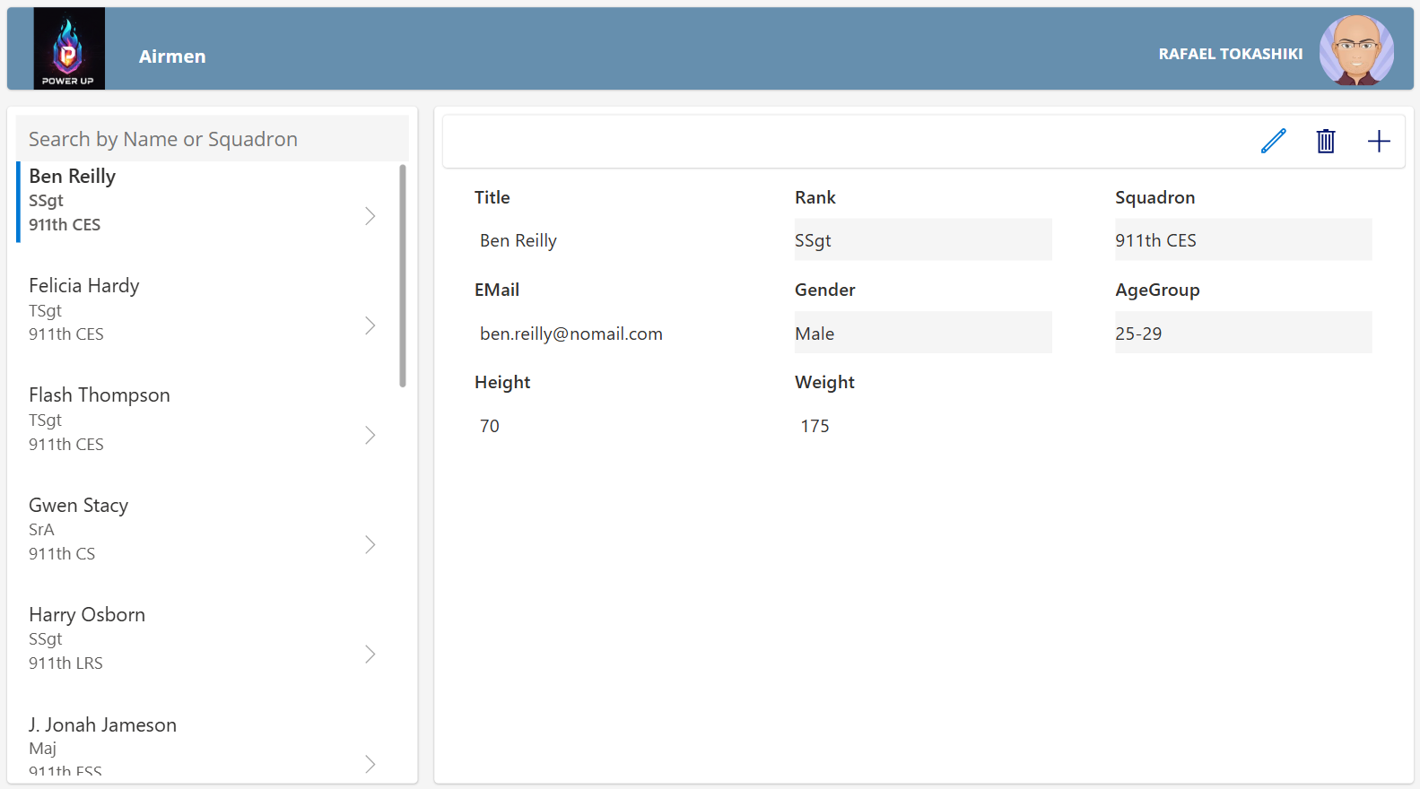
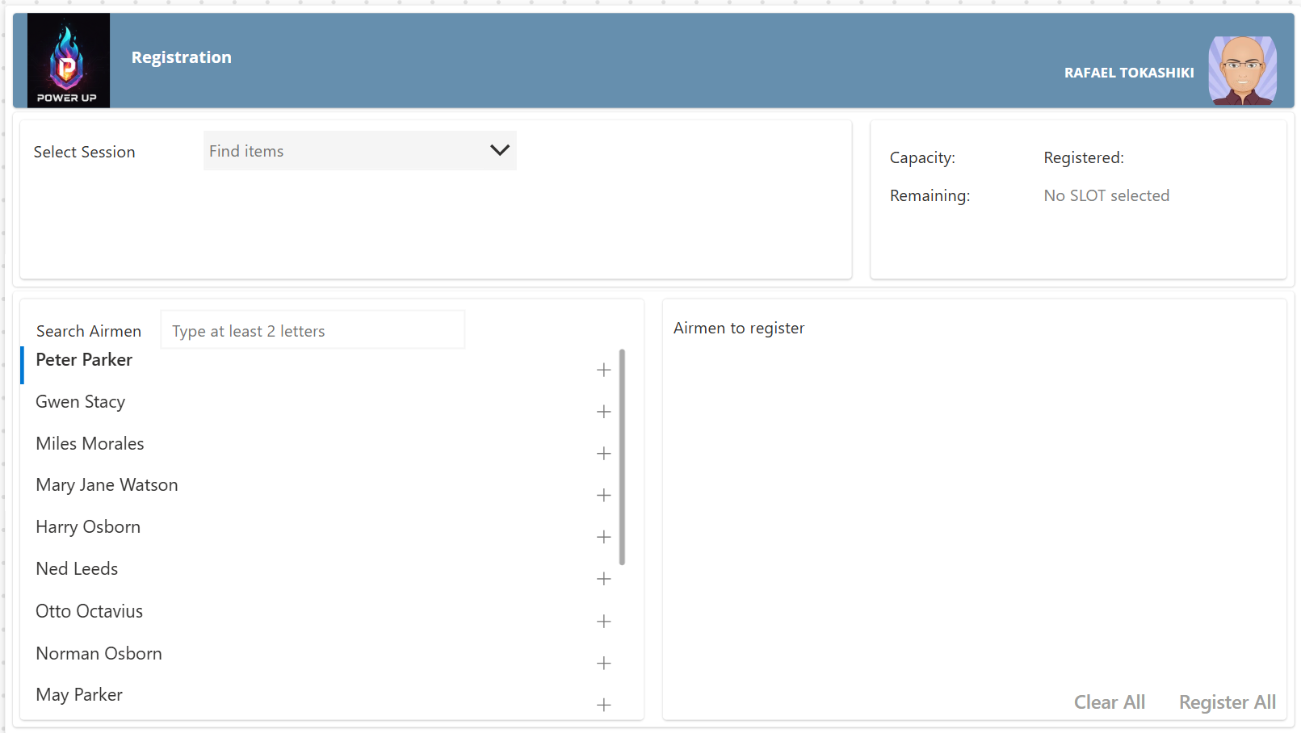

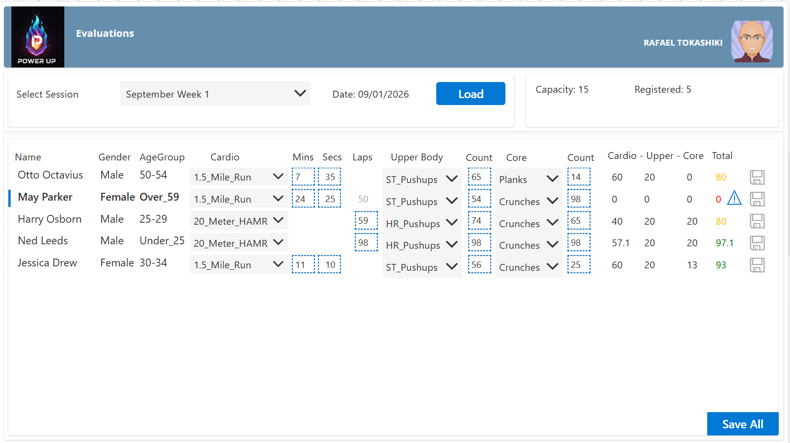

- Notifications
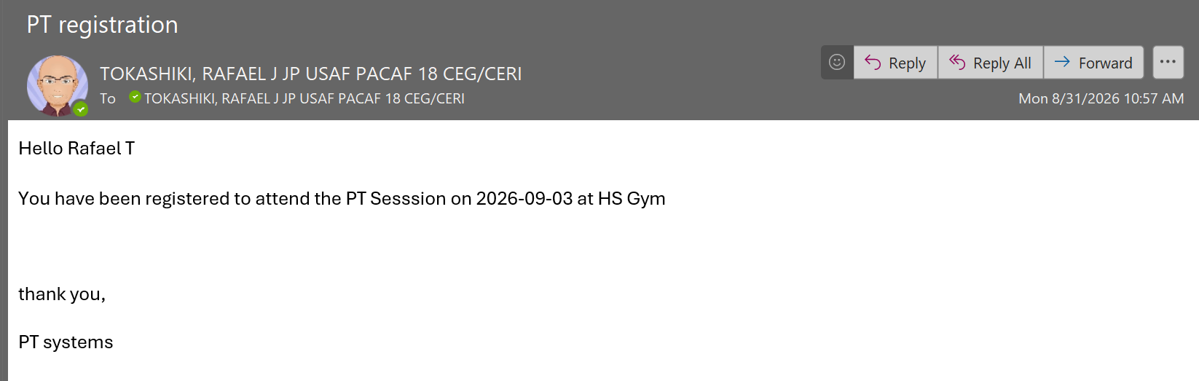

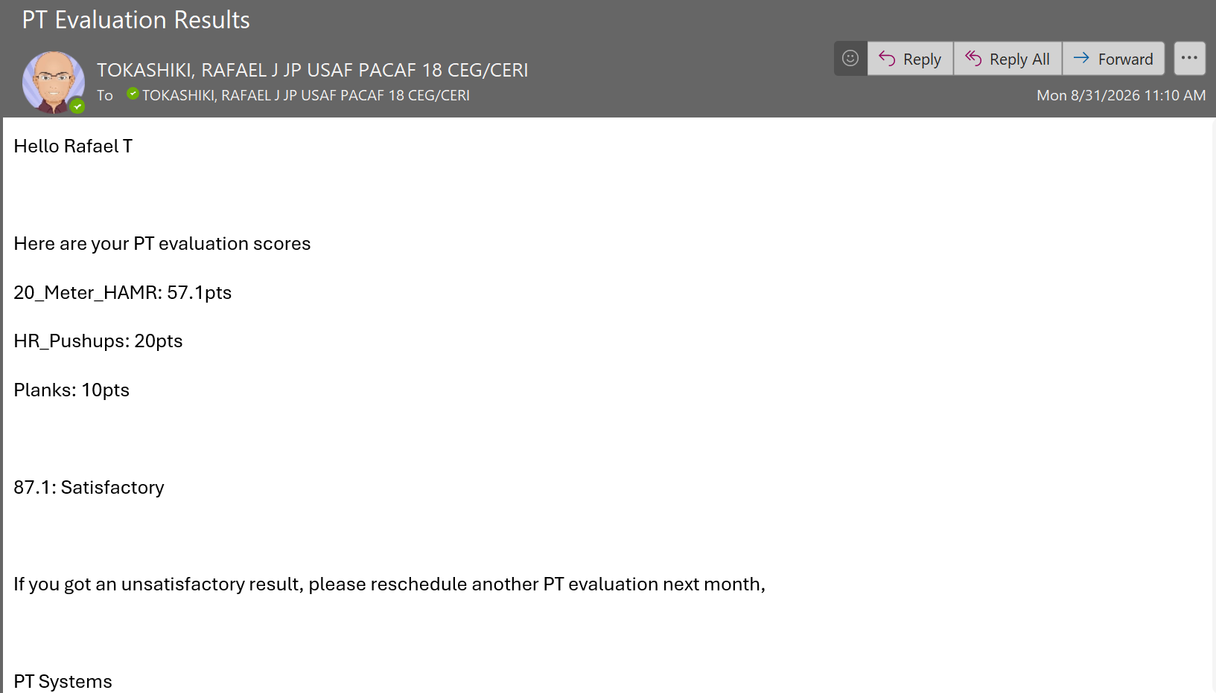

- Business Intelligence
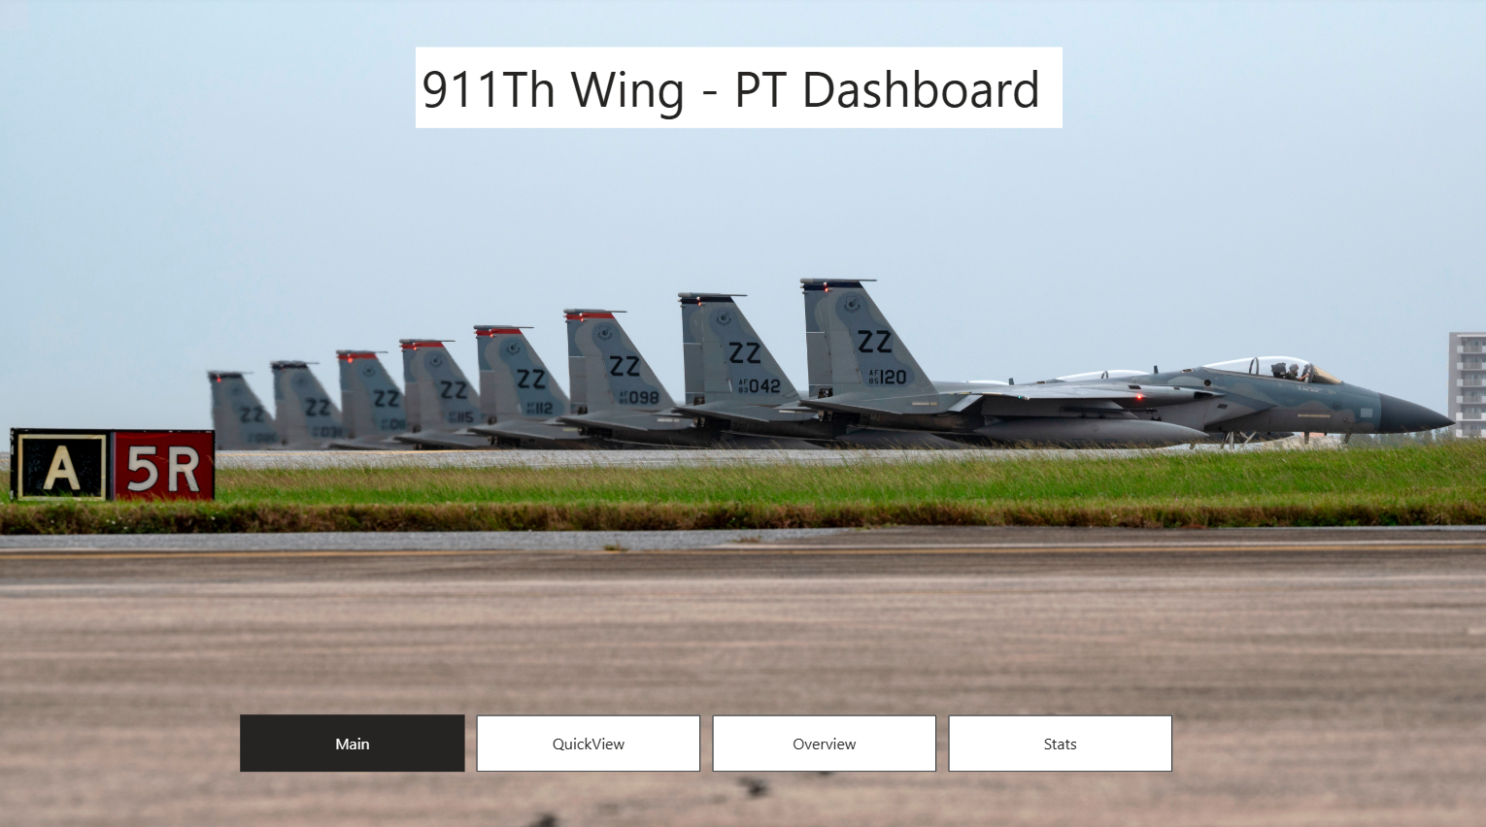
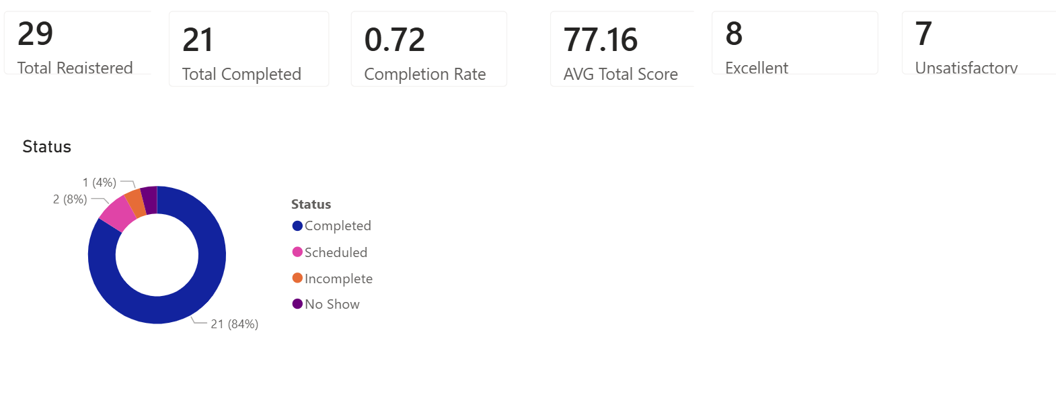
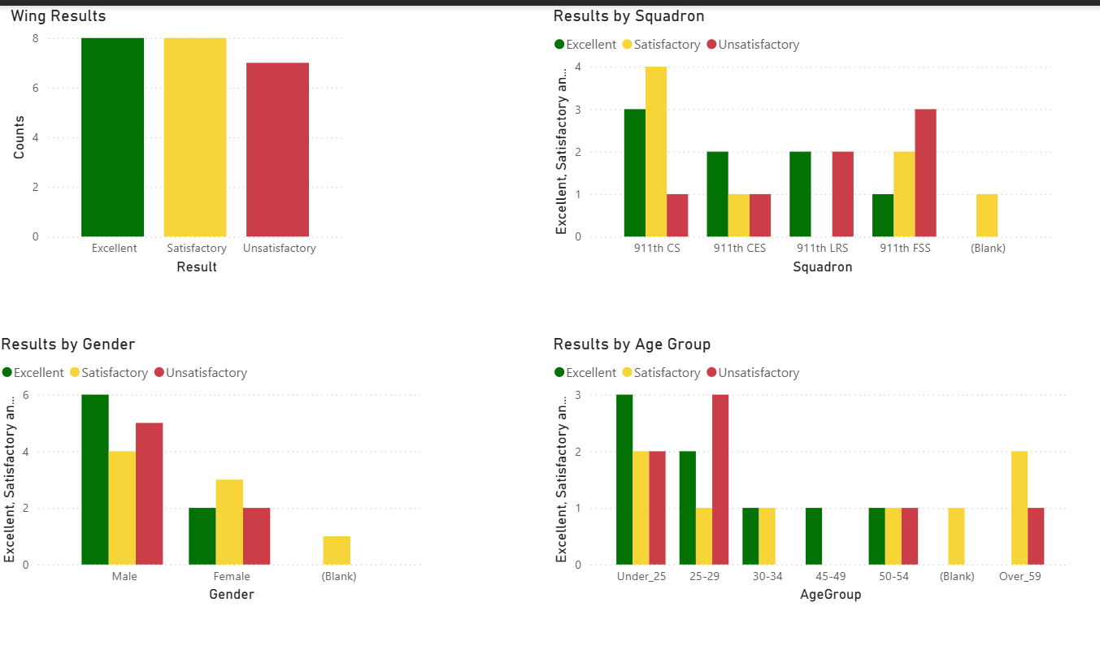
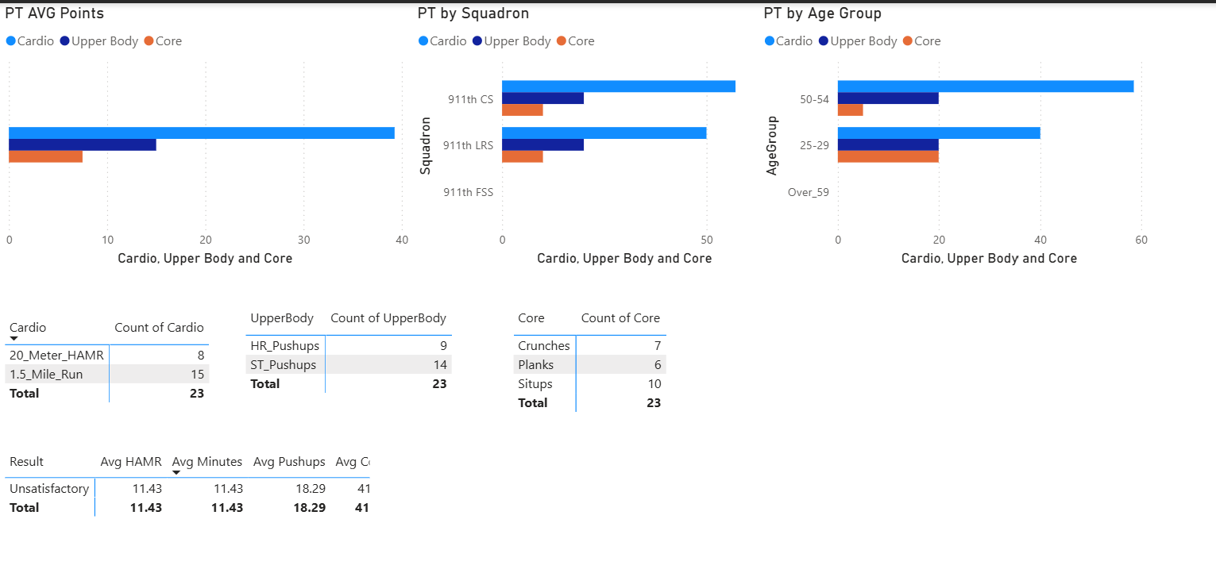

Microsoft Learn Resources
The links on this page are just the starting point to the tools you will need to complete this challenge. At the end of each module, you will find other related resources which you may need to master the tools.
Content | Link
Introduction to Lists | https://support.microsoft.com/en-US/SharePoint/lists/get-started-with-sharepoint/introduction-to-lists
Go further with lists | https://adoption.microsoft.com/en-us/microsoft-lists/microsoft-lists-virtual-workshop/
Build a canvas app | https://learn.microsoft.com/en-us/training/paths/create-powerapps/
Advanced canvas app | https://learn.microsoft.com/en-us/training/paths/advanced-canvas-app-development-mastering-formulas-techniques/
Power Apps | https://learn.microsoft.com/en-us/power-apps/
Automations with Power Automate | https://learn.microsoft.com/en-us/training/paths/demonstrate-capabilities-microsoft-power-automate/
Automate business processes | https://learn.microsoft.com/en-us/training/paths/automate-business-processes-power-automate/
Getting started with Power BI | https://learn.microsoft.com/en-us/training/modules/get-started-with-power-bi/
Design reports | https://learn.microsoft.com/en-us/training/modules/power-bi-effective-reports/
Extras | Good content but not needed for this challenge
Build your data model with dataverse | https://learn.microsoft.com/en-us/training/paths/build-data-model-microsoft-dataverse/
Plan | https://learn.microsoft.com/en-us/power-apps/maker/plan-designer/plan-designer  https://learn.microsoft.com/en-us/training/modules/plan-app-project/
Create a solution | https://learn.microsoft.com/en-us/power-apps/maker/data-platform/create-solution
Generative AI | After watching Microsoft learn resources and related content, feel free to use generative AI tools. However, keep in mind that you are ultimately responsible for what you do with the AI recommendations.

